IMAA Technical Coaching Course

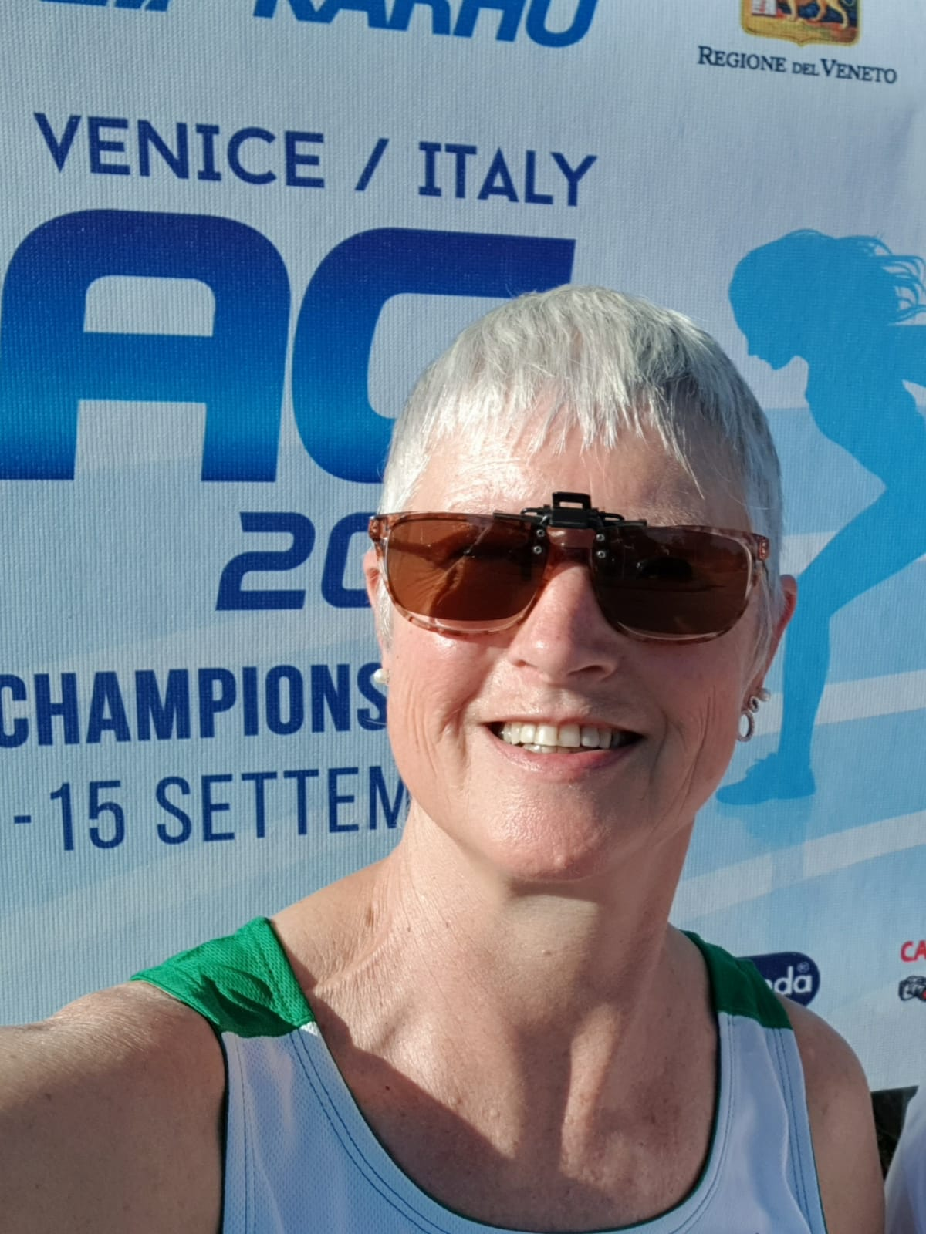
High Jump & S & C Coach

Lucy Moore is a Level 3 Jumps Coach and a Level 1 Weightlifting coach. She represented Ireland as a senior athlete in the European Cup in the heptathlon. She won gold at the World Masters Indoor high jump and has also won gold in the World Masters Weightlifting Championships. Lucy was National Event Coach for high jump for over a decade and is best known for coaching Deirdre Ryan & Pamela Hughes (HJ) and David Gillick & Claire Bergin (400m). She was Head Coach in DSD AC for many years.

Shot Putt Coach
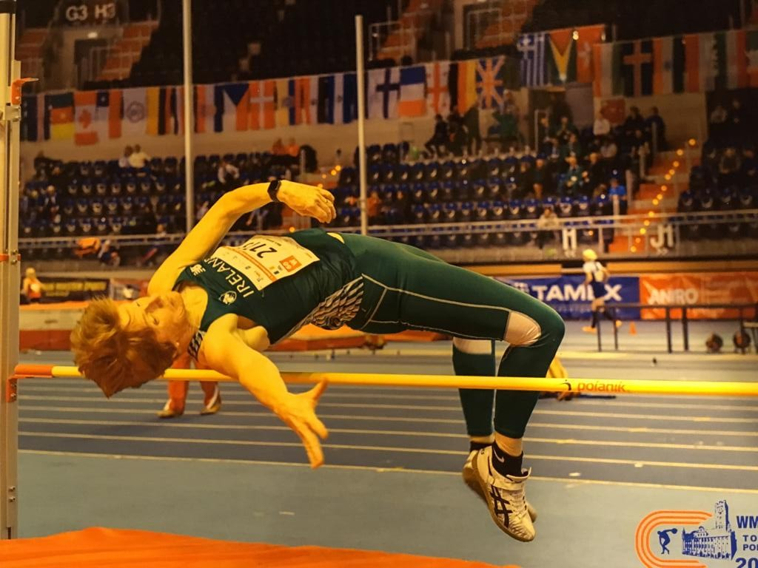
Mary Barrett is a level 3 combined events coach and in the process of completing a degree in strength and conditioning. She represented Ireland as a senior athlete in the Heptathlon at the European Cup. She has won various medals at World and European Masters in hepthalon, shot put, javelin, hurdles and high jump. Mary has coached Connacht squads and Irish schools teams for over 30 years. Her coaching career started with Melissa Collins 80m Hurdles, Maolissa Hynes 300m Hurdles, Alva Darcy 100m, Laura Shaughnessy cross country, Olive Loughnane the World 20km race walking champion. To the present day Brendan Lynch 400m hurdles triple jump and pentathlon, Aoibhinn Farrell 80m hurdles, long jump, triple jump and high jump and Caoimhe Farrell 80m hurdles, long jump and high jump.She also works with students with special needs and special Olympics and Irish wheelchair.

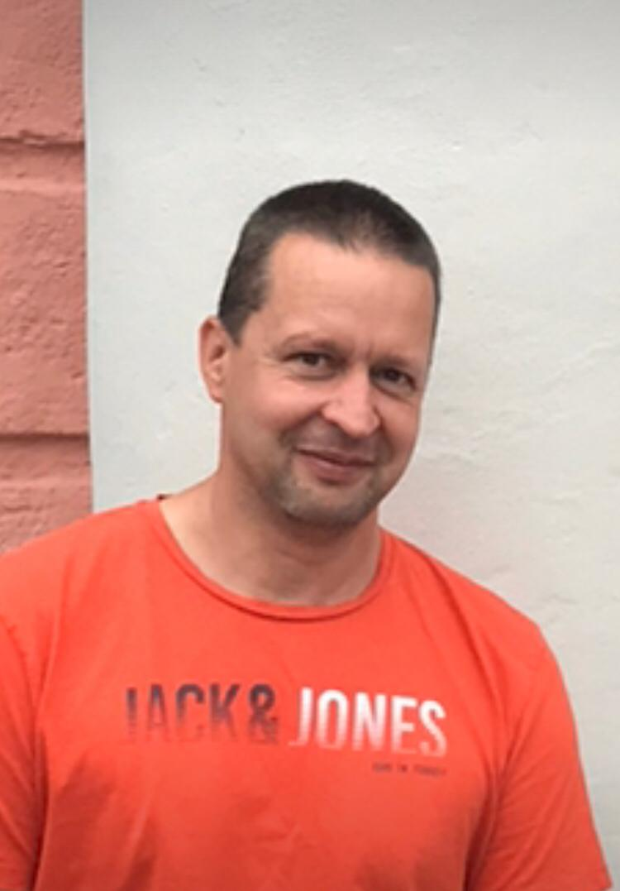

Long Jump Coach

Steffen Fleischer is a Level 4 jump coach for long jump, high jump and triple jump. He is also a Level 2 coach for sprints and Level 2 Coach Education Tutor. He has coached athletes for over 14 years now of all ages and brought many athletes to National and International success. While he is mainly a coach in Celbridge AC he has also been involved in various Performance Squads including the National Combined Event Squad and National Jump Squads and Leinster/Dublin Performance Squads.
Sprint / Relay Coach
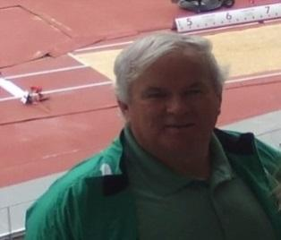
Brian Corcoran is a Level 3 Coach having competed with Raheny shamrocks for some years he soon got into coaching and has been coaching now for approx 40 years. Over the years he served as national event coach for 400mts and 4x400 mts relay teams. Fast forward to the early 2000s, after a few years away from athletics, he again took over as national event coach for hurdles as well as working with National relay teams. In more recent times he has worked with a small but successful group who have again won National titles at junior, under 23, varsities and senior level. This was from 60mts indoors up to 1500mts both indoor and outdoor events. This also included National 4x100m squads at Under 23 and senior level. Today he still coaches and enjoy working with athletes at club and National level. This currently includes the women’s senior and under 23, 4x400m squads

Hurdles Coach - November 17th

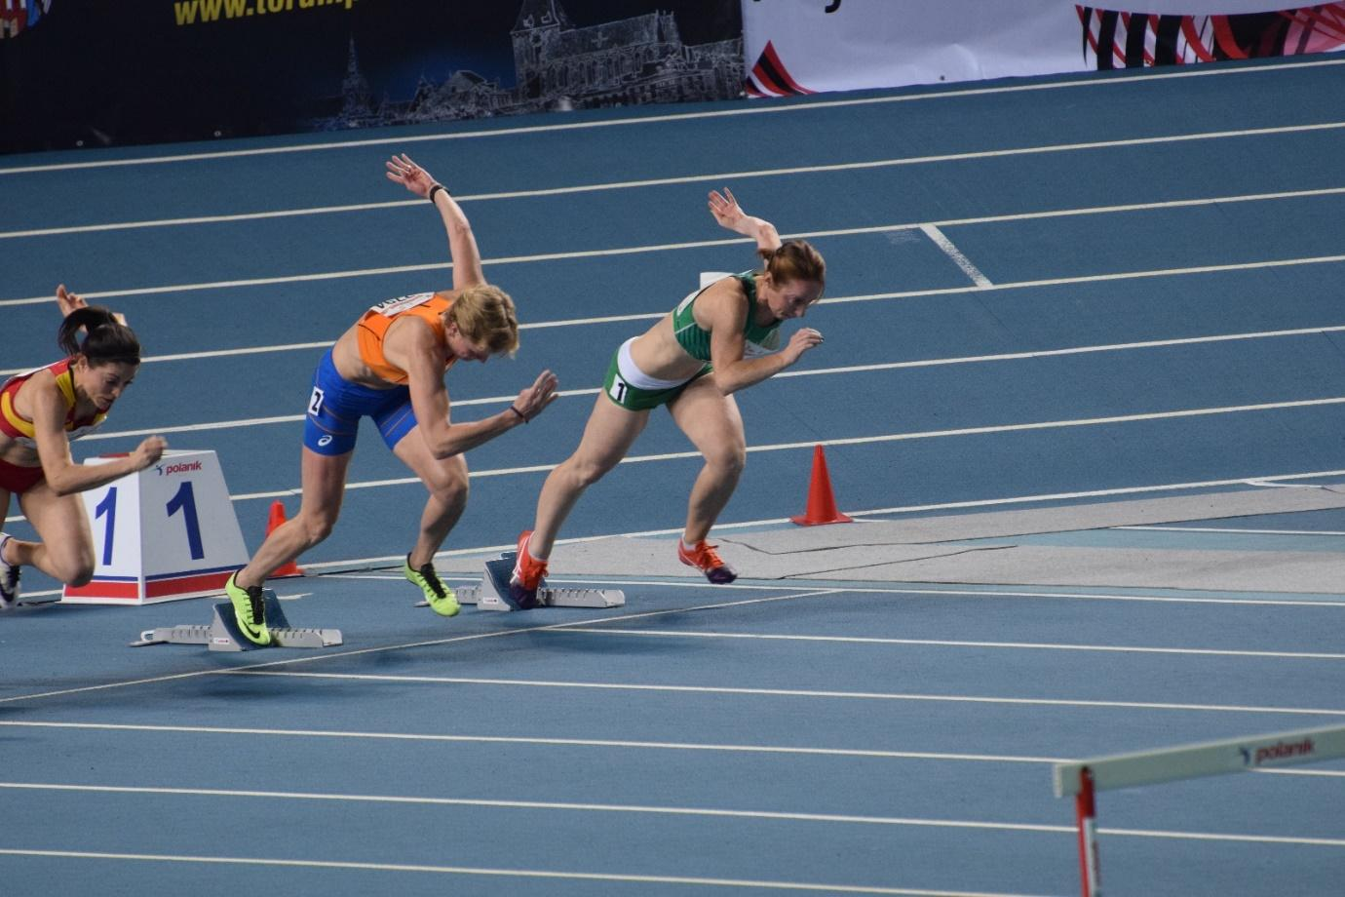
Avril Dillon is a Level 4 Hurdles and Sprints coach who took up the reins as coach for the DSD AC Senior and Master sprint team in September 2016 and coached for 6 seasons. She had returned from the UK having held the position of Head Coach to the Oxford Brookes University Athletics Club for 7 years and was responsible for the overall training and competition programme for each team from the track, field and middle - distance squads. With her athletes getting victories at European Sprint Duathlon Championship and two gold medals in European Student Triathlon Championships, and these athletes have subsequently gone on to become members of the GB National Triathlon and Indoor Cycling Teams. An athlete herself Avril has won 44 National medals (approx.) to date, from Junior, University, Senior and now Masters level and holds the national indoor hurdles master’s record.

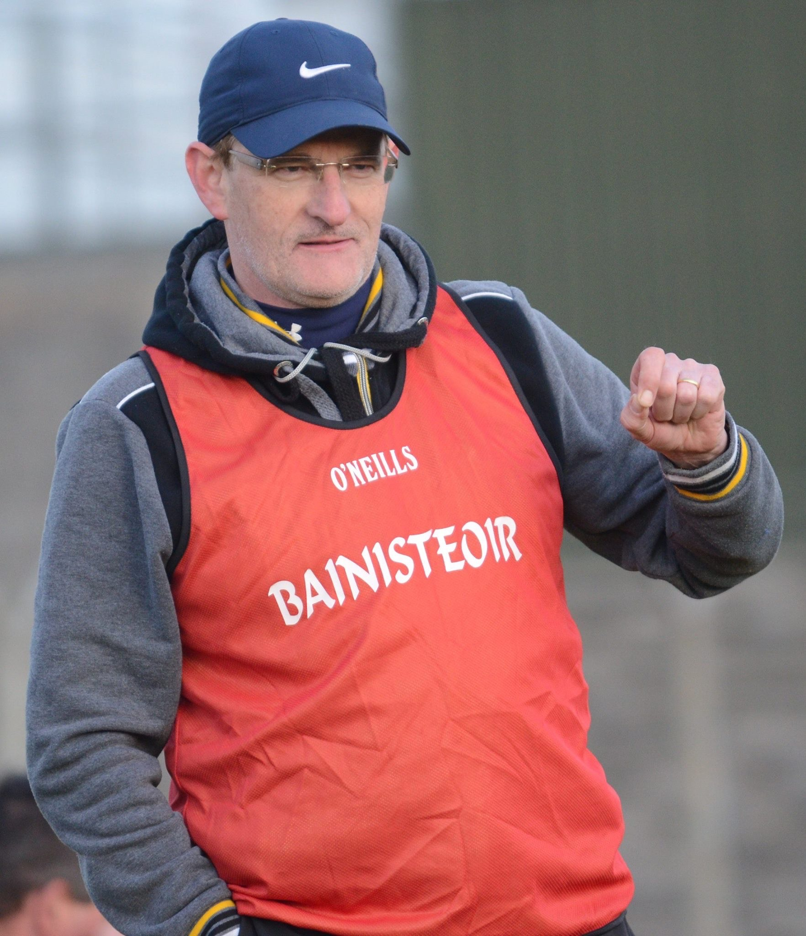
Hurdles/Relay Coach - December 1st

Ciarán Conlan is a IAAF level 5 jumps coach and a former National Jumps coach, he is currently coach to Irish Senior and U23 4x100m relay teams. He is also a coach education tutor for AAI. He has been coaching at Navan AC since 1990. He is a former 400-800m athlete. He is a retired teacher presently working in primary schools in South Dublin introducing athletics in PE curriculum.

